From: http://www.moneyweek.com/investments/precious-metals-and-gems/is-the-gold-market-really-rigged-14501.aspx
By Dominic Frisby Jan 21, 2009


What's going on with gold?
Twice a day – at 10:30AM and 3PM - the price of gold is set on the London market by the five members of the London Gold Pool (HSBC, SocGen, Deutsche Bank, Scotia-Mocata and Barclays). This is known as the London fix and it's used as the benchmark to price gold, gold products and derivatives in markets around the world.
I've been looking at some charts and an astonishing pattern has become apparent. It's a pattern which, if you'd traded it methodically, would have earned you 1% every 20 days over a period of 24 years. That compounds to a staggering 2,050%!
What is this spectacular strategy? Read on…

The astonishing pattern in London gold fixing
The strategy is really quite simple. You buy gold at the London PM fix (3PM), as the American markets have just opened for trading, and you sell your gold the following morning at the London AM fix (10:30AM), as the Asian markets are closing.
My thanks, as always, to Tom Fischer of Herriot Watt University for the charts below. The first demonstrates the 20-day 1% gain that would have been yours since 1985 (the green line).
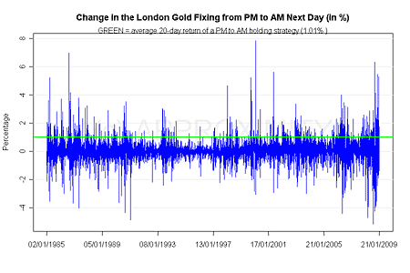
And, as our next chart shows, if you reversed the strategy, bought gold at the AM fix and sold at the PM fix, you'd be down a bankrupting 0.67% per 20 days.
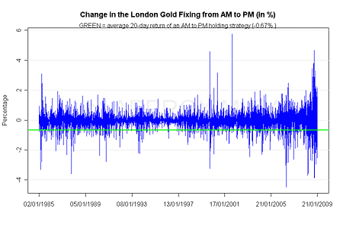
What is more astonishing is how this pattern has accelerated since 2007. Sell gold in the morning, buy it back in the afternoon, and a cool 1.78% 20-day profit will be yours:
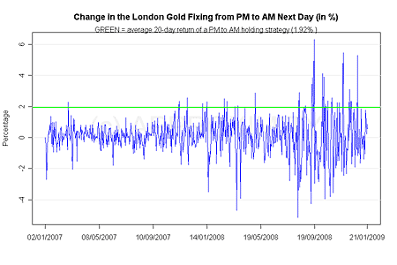
Do the opposite, however, and you'd have suffered a 20-day loss of 0.86%, despite the fact that gold is in a runaway bull market.
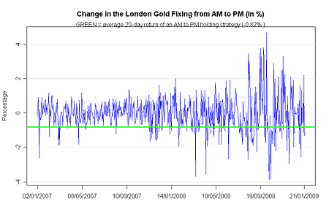
The trouble is, of course, that transaction costs all but invalidate this strategy. But there is nevertheless a great deal we can read into this pattern.

Why would anyone want to manipulate the gold price?
What other free market shows such a consistent behaviour over time? Unless, of course, it's not a free market and the invisible hand of Big Brother is getting involved. Many of you will have read about manipulation of the gold price, and heard that there is a deliberate conspiracy to suppress the price of gold.
Every time I hear the words 'manipulation' or 'conspiracy', my every instinct screams 'No'. There must be a less Machiavellian solution – most conspiracy theories are poorly researched and facile. But several people have done excellent research into this one, including James Turk of Goldmoney, the people at GATA and Paul Mylchreest in his Cheuvreux-Credit Agricole Report.
Why would anyone want to manipulate the gold price? Well, despite the fact that is is of barely any industrial use, gold is a highly political metal and a runaway gold price – which, by the way, we will eventually see, I am sure – tells you 'something is rotten in the state of Denmark'. If people are rushing to buy gold, it shows they do not trust the government to maintain the value of paper currency. So the aim of the manipulators, the theory goes, is to devalue gold and preserve the status of unbacked government currencies such as the dollar.
One reason for the theory is that there is more gold and silver sold on the Comex (the US commodities exchange) than is actually possible to deliver. In the case of silver, more is sold than is actually mined on an annual basis.
And certainly, the remarkable trading pattern of the London PM and AM fix adds more weight to the theory that the West is selling gold during Comex opening hours, possibly to suppress the price.
On the other hand, of course, we have Occam's Razor – lex parsimoniae. This is the principle that the simplest solution is the best. So, rather than resorting to some mass conspiracy theory, could the answer be that Asians are buying gold and Westerners are selling just because Asians like, value and appreciate gold more than we do?
Whatever the reason for this price pattern, this transfer of gold from West to East is yet another demonstration, if you needed it, of the generational shift in wealth and power that is taking place. After all, they say that 'he who owns the gold makes the rules'.

An interesting statistic for you
Finally, before I go, here's an interesting statistic for you: the first fixing was in September 1919 when the gold price was £4 18/9d per ounce. It's now more than £600. My, how well sterling has maintained its purchasing power. Here's a chart that tells you what a rotten investment the British pound has been ever since we came off the gold standard in 1914. It comes from a House of Commons research paper (03/82 11 Nov 2003 [pdf]) – so they know.
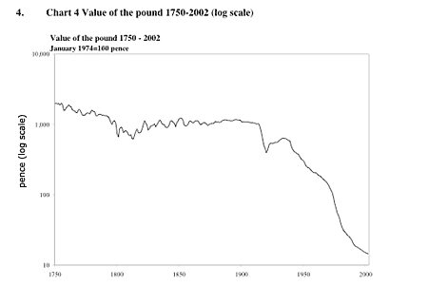
That decline, as we all know, has accelerated somewhat in the last six months. And the reception to the latest banking bail-out suggests it won't stop falling any time soon.

